

FACULTY OF INFORMATION TECHNOLOGY AND ELECTRICAL ENGINEERING

**Furqan Ahmed**

**CrowdPickUp: Crowdsourcing Task Pick-up**

Master’s Thesis

Degree Programme in Computer Science and Engineering

December 2016

**Ahmed F. (2016) CrowdPickUp: Crowdsourcing Task Pick-up.** University of Oulu, Degree Programme in Computer Science and Engineering. Master’s Thesis, 50 p.

Abstract

In the field of crowdsourcing, this thesis studies the efficiency and performance of different types of crowdsourcing tasks i.e., Situated, Location-based and Typical crowdsourcing and also focuses on the users on how they interact with the system and their behaviors with Situated, Location-based and Anywhere crowdsourcing. There is extensive research on Situated, online and mobile crowdsourcing but not on anywhere and location-based crowdsourcing.

The key findings demonstrate the performance of appropriately designed crowdsourcing tasks in a composite environment. In this study we also observer the behavior of the users performing Situated, Location-based and anywhere crowdsourcing tasks. We record their average time completion of the different tasks, which type of crowdsourcing task they performed the most and how accurately they answered the question based on ground truth of these crowdsourcing tasks. We have tested a paid crowdsourcing system in which the users can use their earned coins through completed tasks and can buy items of their own choice through our web shop integrated within our crowdsourcing system.

Towards the end of the thesis, we would be revisiting research question and the research agenda of our work. We would also be discussing the merits and demerits of the different types of crowdsourcing and their related tasks based on the user input and usage of the system. Finally, we would be concluding the thesis by stating again our research agenda, demonstrating the known issues, challenges and our possible future work within this area.

**Keywords: Crowdsourcing, Situated Crowdsourcing, Crowdsourcing Task pickup, Location-based task pickup, QR Scanning, ground truth.**

**Ahmed F. (2016) Diplomityön nimi.** Oulun yliopisto, tietotekniikan tutkinto-ohjelma. Diplomityö, 50 s.

Tiivistelmä

**Alalla crowdsourcing, opinnäytetyö tehokkuutta ja suorituskykyä kolmenlaisia ​​crowdsourcing eli sijaitseva, Location-pohjainen ja Anywhere crowdsourcing ja keskittyy myös käyttäjille, miten ne ovat vuorovaikutuksessa järjestelmään ja niiden käyttäytymistä kanssa sijaitseva, Location-pohjainen ja Anywhere crowdsourcing. On laajan tutkimuksen sijaitseva, online-ja mobiili crowdsourcing muttei missään ja sijaintiin perustuvia crowdsourcing.**

**Keskeiset havainnot osoittavat suorituskyky on suunniteltava crowdsourcing tehtävät komposiitti ympäristössä. Tässä tutkimuksessa myös tarkkailija käyttäytymistä käyttäjät voivat suorittaa sijaitseva, Location-pohjainen ja missä tahansa crowdsourcing tehtäviä. Me nauhoittamaan keskimääräinen aika loppuun eri tehtäviä, minkä tyyppinen crowdsourcing tehtävän he esiintyivät eniten ja kuinka tarkasti ne vastasi kysymykseen perustuu kentällä totuus näistä crowdsourcing tehtäviä. Olemme testanneet maksettu crowdsourcing järjestelmä, jossa käyttäjät voivat käyttää ansaittu kolikoiden suoritetut tehtävät ja voi ostaa tuotteita oman valintansa kautta verkkokaupastamme integroitu meidän crowdsourcing järjestelmässä.**

**Loppupuolella Työn, meillä olisi tarkistamassa tutkimuskysymys ja tutkimusagendasta työmme. Haluamme myös keskustella eduista ja haitoista erityyppisten crowdsourcing ja niihin liittyvien tehtävien perusteella käyttäjä syöttää ja järjestelmän käytön. Lopuksi olisi tekemistä tutkielman toteamalla jälleen meidän tutkimusohjelman, osoittaa tunnettuja ongelmia, haasteita ja meidän mahdollista tulevaa työtä tällä alueella.**

**Avainsanat: Crowdsourcing sijaitsee crowdsourcing, Location-pohjainen crowdsourcing, minne tahansa crowdsourcing, QR skannaus ja kentällä totuus.**

Table of contents

Abstract

Tiivistelmä

Table of contents

Foreword

Abbreviations

1. Introduction 7

1.1. Objective and Scope of thesis 7

1.2. Structure of thesis 7

2. related work 8

2.1. Situated Crowdsourcing 8

2.2. Mobile Crowdsourcing 8

2.2.1. Completing Crowdsourcing Tasks on the Go 8

2.2.2. Location-based Crowdsourcing 9

2.3. Micro-tasks in Crowdsourcing 10

3. proposed approach and implementation 14

3.1. Overview 14

3.2. Implementation Process 15

3.3. System Architecture 15

3.4. User Interface Development 17

3.5. System Backend Development 17

3.6. Mobile and Desktop Clients 18

3.7. Secure Communication 18

3.8. Dashboard 19

3.9. Shop 19

3.10. Help Menu 19

4. study design & evaluation 20

4.1. CrowdPickUp 19

4.2. User Management 19

4.3. Situated Crowdsourcing Tasks 19

4.3.1. Object Translation 16

4.3.2. Hobbies In Oulu 16

4.3.2. Student Housing 16

4.4. Location-based Crowsourcing Tasks 19

4.5. General Tasks 19

4.5.1. Sentiment Analysis 16

4.5.2. Visual Analysis 16

4.5.3. Word/Topic Relevancy 16

4.6. Survey 19

5. results 20

5.1. General Statistics 19

5.2. Survey Results 19

5.2.1. Age 16

5.2.2. Gender 16

5.2.3. Education Level 16

5.2.4. Field Study 16

5.2.5. Living 16

5.2.6. Worker 16

5.3. Performance 19

6. Conclusion 20

7. References 21

8. Appendices 22

Foreword

This thesis work has been carried out at the Center For Ubiquitous Computing, University Of Oulu, Finland under the supervision of Professor Vassilis Kostakos and Dr. Jorge Goncalves. I would like to express my sincere gratitude to Professor Vassilis Kostakos and Dr. Jorge Goncalves to give me this opportunity to work on this thesis and under their teachings, supervision and with their help and support I have been able to achieve this milestone. The learning outcome while working on this project was awesome and I had a chance to use today’s innovative technologies to study and implement this research. Thanks to my professor’s and supervisor’s for their continuous help and support.

Finally, I would like to thank my family, friends and all others who support me and guide me in every phase of life.

Oulu, 31.10.2016

Furqan Ahmed

Abbreviations

The abbreviations will go here.

# Introduction

Introduction part will go here.

# related work

**2.1 Situated Crowdsourcing**

There have been plenty of researches on situated crowdsourcing. Amongst many examples, Bazaar [31] a Situated Crowdsourcing Market which uses kiosks to enable researchers to deploy simple crowdsourcing tasks to be placed in different locations for the workers to participate. The study consist of three main components i.e., a grid of kiosks contains Android tablet which is set to kiosk mode and an active internet connection to connect to the server, a server on which a middleware was deployed to communicate between android device and MySQL database. The middleware was developed on Slim micro framework which is a lightweight PHP framework to develop web applications and APIs and the third component is a Researcher/Administration Hub to allow researchers to manage tasks and to oversee the whole system using the Hub.

Working with crowds [26], is a study, which systematically investigate workers behavior and response to economic incentives in a situated crowdsourcing market. The study shows that in order to recruit workers and to obtain situated crowdsourcing contributions a market-based model is a sustainable approach. The study also suggested that price mechanism is an efficient tool through which the supply of labor can be adjusted in a situated crowdsourcing market. Another study [45] carried out in health care domain where a project is developed to reduce the stress level and increase the restoration opportunities of the hospital staff, which as a result improve the physical environment of a hospital emergency department. The study outline a pragmatic participatory method, which uses social software implemented on situated interactive displays.

The study [44] is a dialog system based on situated crowdsourcing, which addresses the issues arises when data collection of user queries to situated dialog system in a moving car. The situated crowdsourcing study compares the queries collected using the crowdsourcing methods to those collected using a real situated dialog system and evaluated on based on similarity in semantic content, naturalness of language expression and bias of the collected data. Crowdsourcing queue estimation in situ [43] is another study based on situated crowdsourcing mechanism that estimates queue length in real time. The system relies on public interactive kiosks to collect the human estimation about their queue waiting time without interfering into billing or customer systems in order to determine whether people who just joined the queue would differ in their estimates from people who were in the front of the queue.

Situated Crowdsourcing can be very useful for our urban environments [46], the study proposes a future view of crowdsourcing-enabled urban environments which can enable a flexible situated collaboration pattern and through crowdsourcing a way to contribute to the wealth and quality of life of urban environment can be promoted. The study also presents several case studies on how these environments can have a high impact from the individual and societal point of view, along with the challenges that could be faced in order to implement these environments to make them come in to reality. MOOC (Massive Open Online Courses) [47] which are the main buzzwords in education field, the study is supporting crowdsourcing in MOOCs informal face-to-face meetings. In MOOCs, the online courses are characterized by the openness of their content and are typically packed in video format by the large number of participants, which make distributed communities around the world that can physically meet periodically and share their thoughts, discuss about the MOOCs topics and help student to overcome their problems. At the end of the meeting, a conclusion is made that can be used as a starting point for other meetings that are held at other locations. The study demonstrates how this learning could leverage the use of tags to connect MOOCs with face-to-face meetings and tag-based authoring tool etiquetAR tool to provide a structure and a conclusion at the end of the meeting.

The study [48] recognized the importance of civilian-initiated activities during disaster situations and use crowdsourcing to manage the voluntary activities during these emergencies. The study demonstrates two tools that surround both situated and mobile crowdsourcing concepts. According to the study both situated and ubiquitous crowdsourcing are helpful and appropriate in managing these disastrous situation but still a question arises regarding to the coordination of the volunteers and their activities during these emergencies. The study [54] address the issues that arises in a moving car in understanding of situated language and proposes a method to identify in their surroundings the user queries about specific target objects. Given a visual scene in a situated environment, the study observe the prediction methods of which target object is more likely to be queried and to describe a given target object what kind of linguistic cues user provides. The methods propose visual saliency and crowdsourced statistics as a prior and collect situated utterances from driver using our research system embedded in a real vehicle.

Several studies have surveyed the crowdsourcing system including the mobile crowdsourcing platforms as well as situation crowdsourcing platforms. The study [pii] presented a survey of mobile and situated crowdsourcing systems by addressing questions on how the users contribute to the system when new systems are developed and evaluated. The study analyzes 40 mobile and situated crowdsourcing platforms that are being used in real world and proposed a genetic model and new genes of mobile and situated crowdsourcing systems by examining the user contribution to the systems and discuss how the proposed model can be used to create new crowdsourcing systems. Some examples are shown to show how unique genes inspire new design suggestions to encourage user contributions in mobile and situated crowdsourcing.

Crowdsourcing on the spot [17] study the use of public displays in crowdsourcing mechanism. The study test eight different motivational settings and analyze user behaviors and crowdsourcing performance on public displays. The motivational settings includes accuracy, time spent on each task and task completion etc. The results of the study show that the use of public displays for crowdsourcing mechanism is feasible and through motivational design and validation checks, performance could be improved. In the context of situated crowdsourcing, the study [52] use a crowdsourcing approach to support community-centric use and management of vacant houses. The project is on-going in Kashiwa City in Japan and argue for an open, inclusive and community-centric distributed platform to cater some important needs in the community.

**2.2 Mobile Crowdsourcing**

**2.2.1 Completing Crowdsourcing Tasks on the Go**

The study have shown that the technology has emerged and matured so much that it can be accessed beyond the desktop and situated environments and With such advancements mobile phone have become increasingly popular and useful in today's world of ubiquitous computing. Mobile crowdsourcing have gained a lot of attention from the researchers because almost everyone carry their internet enables mobile phones with them and researchers can design the tasks that the users can complete anytime and anywhere. Crowds are engaged with mobile and hand-held devices to become the source of data by capturing and sharing a sheer amount of data e.g., capturing real world events etc. [1].

mClerk [5] is a mobile crowdsourcing platform that allow users to receive the tasks on their mobile phones through SMS, making it accessible to anyone having low-end mobile phones to high-end smartphones. mClerk is very effective for digitizing local-language documents in the form of text and small images. mCrowd [36] is a platform based in mobile crowdsourcing, that demonstrate and iPhone based mobile crowdsourcing platform that enables mobile users to post and work on sensor-related crowdsourcing tasks and enable the users to fully utilize the rich sensors equipped with iPhone to participate and accomplish tasks on their fingertips.

Twitch crowdsourcing [37] is another mobile crowdsourcing platform that allows its user to put their instant contributions while unlocking their phones each time. The platform takes advantage of the common habit of turning to the mobile phone in spare moments. It spans goals such as authoring a census of local human activity, rating stock photos, and extracting structured data from Wikipedia pages. Using Twitch mobile crowdsourcing platform 82 users made 11,240 crowdsourcing contributions and its median activity took just 1.6 seconds.

Another study i.e., CrowdMAC [38] demonstrated a crowdsourcing platform for mobile access in which mobile users who have sufficient capacity in their data plan, create a market place for mobile internet access by sharing their access to other nearby mobile users for a small fee. MobileWorks [39] is another Mobile Crowdsourcing Platform that is intended to provide employment to the users of developing countries which is a mobile web based application that provides Optical Character Recognition (OCR) tasks to its users that can be completed using mobile web browser. The application divides the documents into different pieces and sends it to different workers to address the limited screen resolution available on low-end phones.

MoneyBee [40] is a unique mobile crowdsourcing platform that use mobile phone operator service instead of conventional internet crowdsourcing approach which has a large subscriber base and the ability to pay task workers using prepaid airtime. The platform assign tasks to its workers on the bases preference, skills, and reliability which is being gathered through the interaction of workers with the crowdsourcing service, the efficient task dispatching minimizes the network load on the operator network.

In the field of mobile crowdsourcing there has been studying in incentivizing the mobile crowdsourcing mechanism, as an example the study [53] focus on the problem of contributor-task matching in mobile crowdsourcing by identifying existing users who poses social media domain expertise like photography etc. and incentivize them to perform some tasks. In the end, the study proposed a framework to extract the contributor’s expertise based in their social media activities and determine incentives for them. The framework evaluated on flickr data for the entire city of Barcelona that shows high level of task quality and wide geographical coverage. In another study [54] which demonstrated an incentive mechanism design for mobile phone sensing by considering two system models i.e., platform-centric model where the crowdsourcing platform rewards the participant users and user-centric model in which the users have more control on the incentives they received. In the study for the platform-centric model the incentive mechanism was developed using Stackelberg Equilibrium and for the user-centric model an auction-based incentive mechanism was developed which is efficient, individual rational, profitable and truthful. Through extensive evaluation for the performance, the theoretical properties of the incentive mechanisms were validated.

Crowdsourcing using smartphones can contribute to novel and complex problem solving [55], the study classifies the mobile crowdsourcing field and through three new applications that use crowd-generated data to optimize location-based search and similarity services. A cloud of more than 40 android devices deployed at the University Of Cyprus to facilitate the research and development of smart phone applications on a massive scale, provided an open test bed. The study in the paper [56] presents CrowdPark, a crowdsourcing-based parking reservation system for Mobile phones that allow the users to “loosely reserve” parking spots. In CrowdPark crowdsource the information about when the parking will be available and this information helps the users to find the parking spots. In designing the study there are several challenges including incentive design, robustness of malicious users, and handling of spatial and temporal uncertainty, which this study addresses that combines protocol design, game-theoretic and cost-benefit analysis, sensor data processing techniques, and navigation-based tools.

The study [57] designed a mobile crowdsourcing system for campus safety, which allow the users to immediately share mass self-reported safety incidents and opportunity to report the witness. The feedback from the study using paper prototype interview, study indicates that it would increase the interactivity amongst the user community and spread the awareness of campus safety. [58]

**2.2.2 Location-based Crowdsourcing**

Mobile Crowdsourcing is also very useful in Location-based crowdsourcing tasks that researchers can design for the workers which they can do using their Internet and GPS enabled mobile phones e.g., going to the specific location and send reports about the environment of the location, sending reports of any instant accident, sending instant notification about traffic or weather situation etc. Several researches have demonstrates the use of mobile phone in the world of crowdsourcing, txteagle [2] is a mobile crowdsourcing platform which allow the users to earn small amount of money in the form of air time or mobile money for which they need to complete small tasks which includes translation, transcription and filling out the surveys using their mobile phones. Askus [3] is another mobile crowdsourcing platform for supporting collective actions and information capture. In Askus, the user is allowed to contact to any person on a certain geographical location and send him/her request to carry out small tasks using their mobile phones. [4] Google uses mobile crowdsouring for live traffic situation, Google Map running on user's phone send the bits back to Google Servers and analyze how fast or slow the user is currently driving.

TRAC [41], tackle the problem of simulating the smartphone users to join mobile crowdsourcing application with smartphones. It takes into consideration the dimension of location information when assigning sensing tasks to smartphones in which as a result the theoretical and computational complexity increases. gMission [42] is another location-based crowdsourcing platform which features a collection of novel techniques including geographic sensing, worker detection and task recommendation. The platform make it possible to implement a new crowdsourcing mode i.e., spatial crowdsourcing in which a requester can ask for resources related a specific location and the worker who is willing to take the task travel to that specific location and get the data.

The study [59] addresses presents a hybrid routing scheme for data dissemination in VANETs and apply location-based crowdsourcing of nearby roadside units (RSUs) to the infrastructural support of inter-vehicular, vehicle-to-roadside, and inter-roadside communications in VANETs and evaluated the performance of the hybrid routing scheme using both simulations and real testbed. The study [60] proposes a framework and studies the preferences and concerns of using Location-based assignments (LBA) and geotagging in news making through crowdsourcing. Task were given to the user and then they were interviewed and asked to complete a questionnaire to get their preferences of receiving tasks and their usage of geotags. This study proposes a framework for participation preferences, which supports future work in Location-based crowdsourcing and to develop new processes and systems.

Researches in Location-based crowdsourcing for Indoor localization are of great importance and attracting many research efforts. The study [64] is a same research effort, which investigates sensors in smartphones that constructs a radio map for a floor plan and designs LiFS, an indoor localization system based on WiFi infrastructure and mobile phones. The study crowdsourced the calibration of finger prints and results in achieving comparable location accuracy as compared to previous approaches. Zee [63] zero-effect crowdsourcing for indoor localization is another similar research effort, which makes the calibration zero-effect by crowdsourcing the training data without any user’s effort by using smartphone sensors. Zee is designed to run in the background of the phone without explicit user participation. Another interesting research [61] uses social media platform i.e., twitter in the context of location-based crowdsourced queries and investigates how feasible is to answer the location-based queries over twitter and more specifically how effective it is to employ location-based services to find appropriate people to answer the given location-based query. The study insights the feasibility of the above stated approach and highlight some challenges in social search engines.

# proposed approach and implementation

This chapter describes the implementation of CrowdPickUp, a crowdsourcing task pickup system, which consists of three different types of crowdsourcing task pickups i.e., Situated, Location-based and General tasks pickup. In CrowdPickUp, apart from the above mentioned tasks types there are other components as well i.e., CrowdPickUp dashboard, online shop, user login, user signup and pickup tasks pages. The components of CrowdPickUp system will be discussed in detail in this section, an overview of our system can be seen in Figure 1 below.

**3.1 Overview**

CrowdPickUp is a crowdsourcing task pick up system, which allow users to pick different types of crowdsourcing tasks from our system. The key component of this system is its different types of tasks i.e., Situated crowdsourcing tasks in which a user needs to have knowledge related to his/her local vicinity [1] in order to complete the tasks, Location-based task pickup in which the user physically needs to be there at the specified location to complete the task by answering about the questions related to local environment and General task pickup in which users will be given the tasks that they can complete and submit from wherever they want regardless of the location and it require user’s basic knowledge to complete the tasks. CrowdPickUp works on every type of client browser either mobile browsers or PC and desktop browsers, the QR codes can be found at arbitrary locations like bus stops, buildings and/or streets from where the users can scan the QR to use the application. QR scanner application is a pre-requisite to access this application however can also use the url directly to access the application. For the Location-based tasks, If the user is submitting tasks using mobile phone then the GPS of the device needs to be activated in order to get the current location of the user to verify the location with the place location. The users are required to first create an account in our system, which will lead them toward the application login and upon successful authentication, the users will be dropped to the tasks screen where they can pick-up their tasks from different crowdsourcing task pickup categories. CrowdPickUp online shop is also an important component of our system, upon completion of each task that users are awarded with virtual coins, which they can use in CrowdPickUp online shop to buy items using their virtual coins. CrowdPickUp dashboard is an another core component of our system which describes the summary of completed tasks by the user including the number of different tasks the user have completed and the number of virtual coins the user have earned.

**3.2 Implementation Process**

The implementation process consists of three phase i.e., Tasks finalization, Database backend development, system backend and UI development. First, the tasks were designed and finalized for each task pick up category i.e., Situated, Location-based and General Tasks in which Situated crowdsourcing section consist of three tasks i.e., Object Translation, Student Housing and Hobbies in Oulu. The General Tasks also consist of three tasks i.e., Visual Analysis, Sentiment Analysis and Topic/Word Relevance and finally the Location-based section consist of only one task but with ten different locations. In the second phase, the database architecture was designed and implemented as per the tasks and system requirement. In the final stage of the implementation process the user interface and the application backend was developed, in which multiple server-side and client side framework has been used to build CrowdPickUp system which will be discussed in the later sections.

**3.3 System Architecture**

CrowdPickUp system is hosted on Amazon Elastic Compute Cloud (Amazon EC2) which provide our system a resizable compute capacity in the cloud. As can be seen in the diagram our Amazon EC2 instance runs on centos (Community ENTerprise Operating System) which is a free rebuild of source packages developed by Red Hat Enterprise Linux. CrowdPickUp has been developed using Java Platform, Enterprise Edition (Java EE) which is a widely used enterprise platform to build enterprise applications using Tomcat as our application server. MySQL is used for database development for adding, accessing and managing application content in the database which is an open-source Relational database management system (RDBMS) and is commonly used in many enterprise applications for its simplicity of use, scalability and memory management etc. The communication between the client browsers and the web server is private and secured with HTTPS, which has been described in section 5.7 below. Figure1 and Figure 2 shows the graphical illustration of CrowdPickUp system architecture and communication.

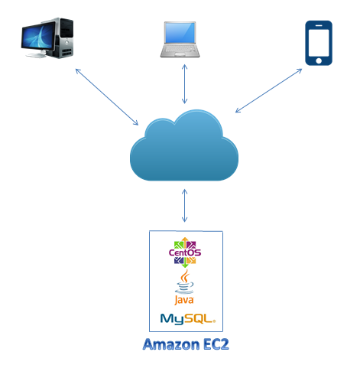

**Figure 1: CrowdPickUp System Architecture Diagram**

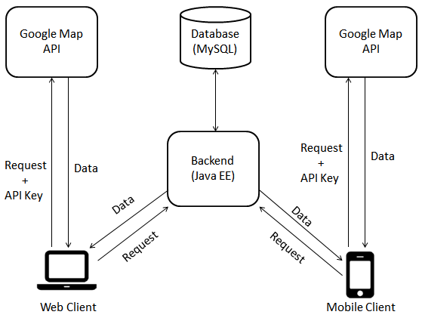

**Figure 2: CrowdPickUp System Communication Diagram.**

The above figure 2 demonstrates the communication of CrowdPickUp system amongst its different components. The communication between the client and server is strictly secured and encrypted through HTTPS and a self-signed certificated has been installed on the server in order to make the communication secured and encrypted. The figure describes the Mobile and Web Client, Backend server i.e., JavaEE having tomcat as an application server, MySQL which has been used as a Database Backend. The clients communicate with the Backend Server requesting the data or sending the data as a response to the server which the Backend Server. The Backend server then send the request or response to MySQL in order to retrieve or save the data to the database backend. Another important component that Figure 2 demonstrate is the communication of client with the Google Map API, the clients send ajax requests to the API using secured channel i.e., HTTPS along with the API Key and the API response back with JSON encoded string that clients parse at their end.

**3.4 User Interface Development**

User Interface Development is one the main component for any web application whether it runs on a mobile client's browser or on a web client browser. CrowdPickUp use Java Server Pages (JSPs) to generate dynamic web pages using simple HTML and CSS code. However, to give web pages more decent and nice look third party User Interface frameworks have also been used i.e., jQuery and Bootstrap etc.

CrowdPickUp is developed to work with every browser from mobile browsers to PC browsers, in order to do this the design needs to be responsive. To achieve this goal we have integrated Bootstrap with our system to manage the responsiveness of the application design. Due to the usage of ready-made code blocks provided by bootstrap the CrowdPickUps user interface was developed rapidly.

**3.5 CrowdPickUp Backend Development**

CrowdPickUp backend development is comprised of JavaEE stack, multiple cutting edge frameworks have been utilized for this purpose. Spring web MVC framework is used to provide model-view-controller architecture to the application and to develop a loosely coupled and a flexible system. Spring MVC gives a modularity to the application code in the form of input logic, business logic and User Interface Logic. One of the key component of the system is user authorization and authentication management and for this reason we have used Spring Security framework which is a JavaEE framework that provides authentication and authorization and access control management to our enterprise application. Hibernate Object/Relational Mapping (ORM) framework which is based on Java Database Connectivity (JDBC) is used which allows fast development of our application and also allow our business code to access objects rather than database tables.

**3.6 Mobile and Desktop Clients**

CrowdPickUp supports cross browser compatibility and responsiveness, the user interface is supported by all types of mobile and desktop client browsers. The application has been tested on devices with different screen sizes and resolutions. CrowdPickUp is capable to run on smartphone browsers, tablet browser and all desktop and PC browsers.

**3.7 Secure Communication**

In CrowdPickUp crowdsourcing task pick-up system, the communication between the web server and the client browser is secured and encrypted which means the communication is done using HTTPS communication protocol instead of common HTTP communication protocol. The purpose of this encrypted communication is to make sure the user sensitive data is private and integral. In order to achieve this functionality we have installed a self-signed certificate on our tomcat application server to make the communication channel secure and private with HTTPS. A basic communication flow between CrowdPickUp System and client browsers are shown in Figure 3.

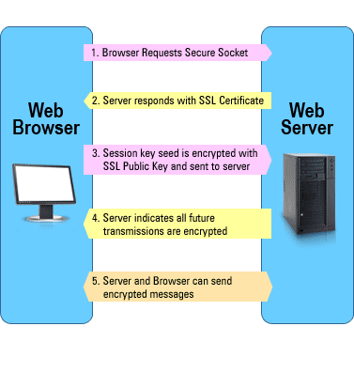

**Figure 3: CrowdPickUp secure communication flow.**

The diagram shows a Secured Socket Layer (SSL) communication between web server and the client browser. First, the client browser request a secure socket from the web server and in response the web server responds with the SSL certificate installed on our tomcat application server. In the second phase of the communication the web client browsers encrypt the session key seed along with the SSL Public key and sent it to our web server and as a result to this the web server indicates that all the future transmissions are encrypted. Finally, our web server and client browsers can send encrypted messages between each other.

**4.2 User Management**

CrowdPickUp is layered with a flexible and powerful authentication and access control framework in order to secure our crowdsourcing platform from unauthorized access and authentication. CrowdPickUp users need to register to the platform using the secure signup page as can be seen in Figure 5 and upon successful login (Figure 5 ) with the credentials the users are able to view and submit the tasks. The user’s password credential is highly secured with md5 hash string and stored in our secured database backend.

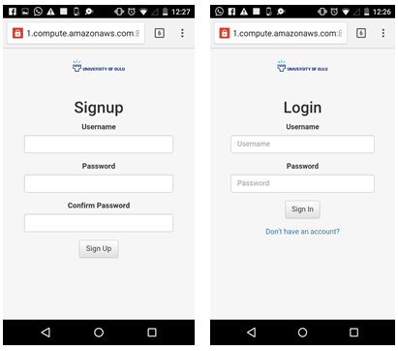

**Figure 5: CrowdPickUp Signup and Login Panels.**

**3.8 Dashboard**

In CrowdPickUp crowdsourcing system, a dashboard has been introduced which shows the summary of the tasks for the current logged In user and the total coins earned by the user. The summary shows the number of individual tasks i.e., Situated, Location-based and the General tasks completed and the overall total number of tasks completed. The CrowdPickUp dashboard screen is shown in the Figure 3.1 below.

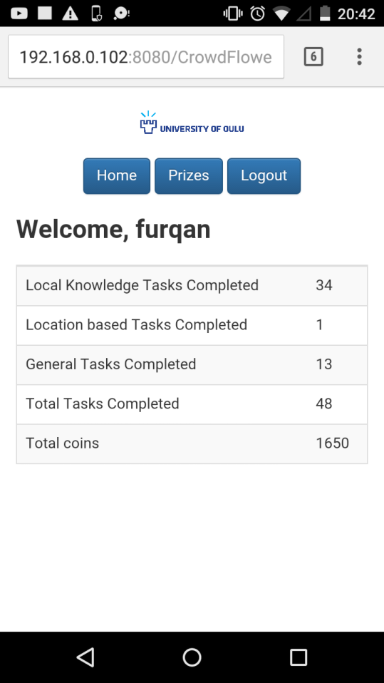

**Figure 3.1 CrowdPickUp Dashboard Screen**

**3.9. Shop**

CrowdPickUp crowdsourcing system rewards its participants through incentives upon completing the tasks successfully. In order to incentivize the participants, we implemented an online shop with different prizes, which allow the participants to purchase the prize of their own choice according to the coins they earned.

In CrowdPickUp crowdsourcing system, there are three different types of prizes available, which the participants can purchase as per the coins they have. First, a ten Euro Voucher and the user need 1000 Coins or more in the account in order to purchase it. Second, a twenty-five euro voucher which require a user to have 2500 coins or more in the account to purchase it and third is a movie ticket which a user can buy If his/her account coin’s balance is nine hundred and seventy five coins or more. A screenshot of prize screen is shown in the below figure.

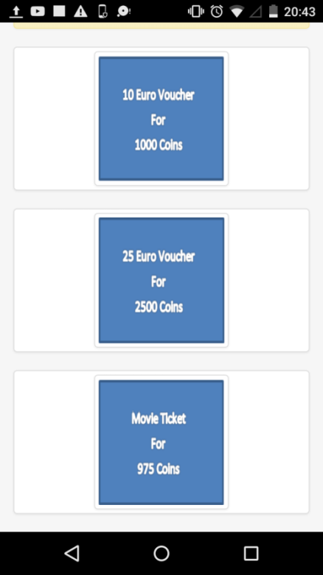

**Figure 3.2 CrowdPickUp Prize Screen.**

**3.10 Help Menu**

For the CrowdPickUp participants there is a help center which can help them understand the project and the ongoing study. The help menu also contains useful email addresses which the participants can use to claim their prizes. A screenshot of CrowdPickUp help menu can be seen in the Figure 3.3 below.

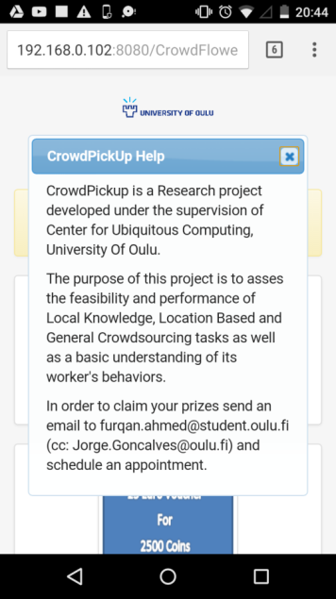

**Figure 3.3 CrowdPickUp Help Menu.**

# Study design

The study of CrowdPickUp crowdsourcing task-pickup system carried out at the campus of University Of Oulu, Oulu, Finland. The study ran for approximately 24 day i.e., from 12th of October until 4th of November and approximately 70 participants actively participates in the study, posters are placed at the notice boards and advertisement boards throughout the university campus so that we can gather as many participants as we can.

The advertisement poster of CrowdPickUp consists of A3 size page with a clear name of the application at the top along with a small description of the project. The middle part of the advertising poster consists of the pictures of the prizes that we offer to the participants upon collecting a certain amount of coins as per different prizes shown in the poster. In order to shorten our application’s URL we use Tinyurl, which is a URL shortening service to provide short aliases for the redirection of long application URL. The bottom part of our advertising poster consists of the shortened URL along with the QR Code to make participants scan it and open the URL in their mobile browsers and start registering to the application an submitting the tasks and win prizes. Some of the participants were from the Department Of Computer Science and they get the application URL instead of scanning the QR Code.

[figures will go here]

All the participants who actively participate in the study incentivized through CrowdPickUps online shop, which can be seen in the above Figure 3.2. In order to claim the prizes, participants need to make a purchase through CrowdPickUps online shop and needs to send an email to the project members to fix an appointment with them in which they need to go through a small interview. One of the project members verify the participant’s purchase and provide them with their purchases as per the department’s policy.

Using our CrowdPickUp crowdsourcing system, we record the opinion or answers from the users along with the completion time for each submission in unit of time i.e., seconds. For the situated tasks we compare the answers with the ground truths of the tasks and record whether the answer is correct or not, but for the object translation tasks in the General Tasks category the identification for the correct and incorrect answer is done manually due to the user input which is in the form of text. The current date time recorded with each task due to its usefulness in the result analysis.

In our CrowdPickUp crowdsourcing study, we design three different sections of tasks i.e., Situated, Location-based and General Task’s section to investigate user’s understanding of different things and places of Oulu and overall Finland. We also investigate how CrowdPickUp system will be helpful for the residents of Oulu City or Finland to learn new things and get to know about new places in this region. With Object Translation Task, participants who are international students can learn Finnish names of different fruits, whereas with Location-based tasks participants can get to know about different locations around City Of Oulu like super markets, beaches, and/or new market places etc. In the same way, Student Housing could be useful for the participants and mostly international students to know about different student housing areas around the city, whereas with Hobbies in Oulu Task, participants can discover new places where they can perform their favorite hobbies around the city. Figure 4 is a tree diagram which shows the structure of different categories present in our CrowdPickUp system along with different tasks associated with these categories.

**Figure 4: Tree diagram of CrowdPickUp crowdsourcing platform**

**4.1 CrowdPickUp**

CrowdPickUp is a crowdsourcing task-pickup system, which consists of Situated Crowdsourcing tasks, Location-based Crowdsourcing tasks and General tasks. The users need to register themselves before in order to participate in the study and to submit the tasks. Upon the completion of the tasks the users are awarded with virtual coins, which they can redeem using the CrowdPickUp online shop by purchasing the vouchers and tickets. The description of individual tasks and their categories are describe in the sections below.

**4.3 Situated / Local Knowledge Crowdsourcing Tasks**

Situated/Local Knowledge task is the first category of our task pickup platform, which requires the workers to have local knowledge related to Finland or Oulu. The tasks are design to allow workers to use their knowledge and experience that they came across while living in Oulu or Finland. Any worker can participate in this category of tasks whether local Finnish resident or any international resident who came to Finland for work or study.

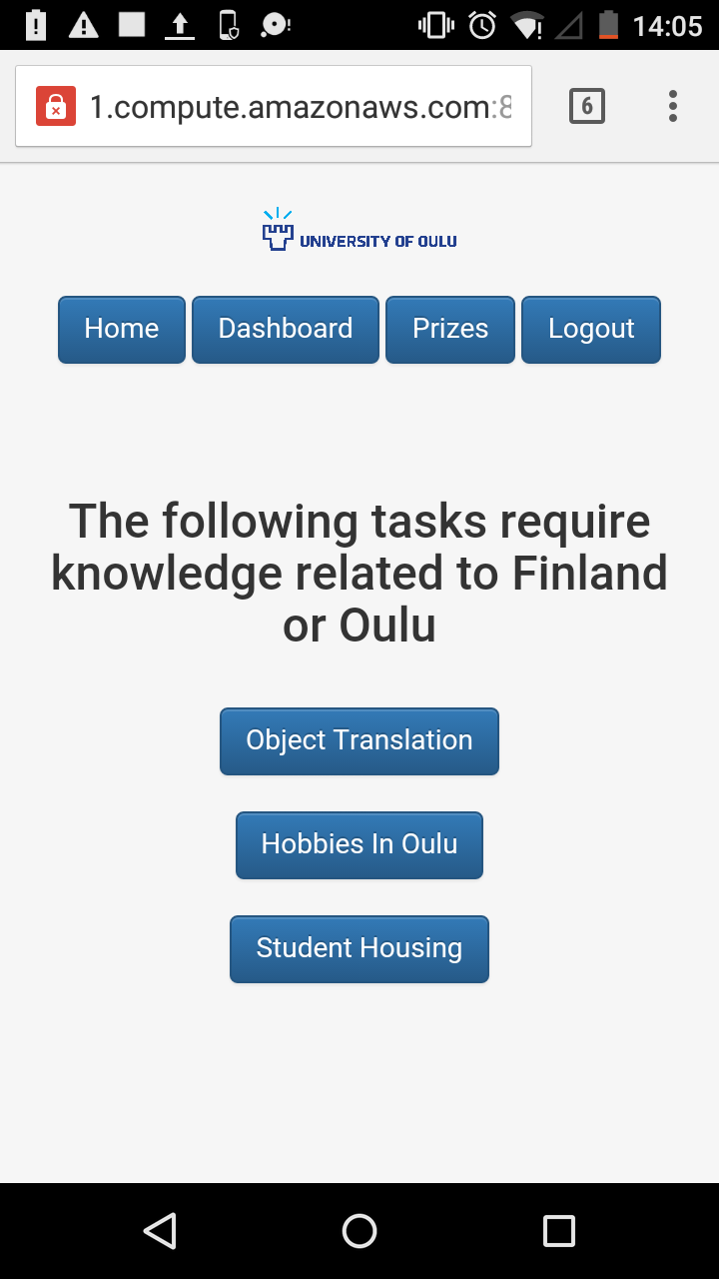

**Figure 6: CrowdPickUp Situated/Local Knowledge Tasks Panel**

**4.3.1 Object Translation**

Object Translation is one of the tasks that reside under Situated/Local Knowledge Tasks category. The workers are required to have basic to intermediate level Finnish language skills. The Object Translation task panel consists of an image of an object particularly a fruit and the workers needs to submit the task by identifying the name of the object and enter its translated text into Finnish. The task can be performed anywhere and contains approximately 50 images of different objects, new object is loaded on the same panel as soon as the worker submit or skip the task. Upon successful submission of the task a worker is awarded with 20 coins whereas upon skipping the tasks a new object is loaded into the panel but no coins are awarded to the workers in this case.

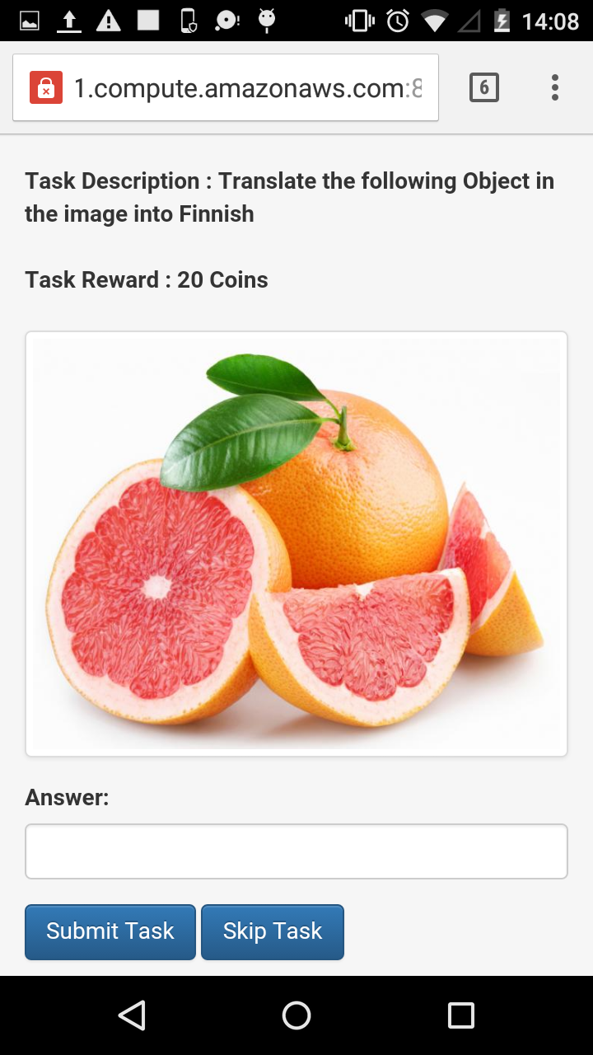

**Figure 6.1: Object translation task panel diagram.**

**4.3.2 Hobbies In Oulu**

Hobbies In Oulu is one of the task which resides under the category of Situated/Local Knowledge task. The workers are required to have knowledge of different places in Oulu. In this task panel the worker will be shown a name of a hobby and the worker needs to enter into the text box describing how this hobby can be carried out in Oulu or Finland by entering how this hobby could be carried out, where is the place situated to enjoy this hobby and what is the best time either winter, summer or day etc. to perform this hobby.

The task can be done and submitted anywhere and it contains approximately 40 different hobbies which a worker can complete and as soon as the task is submitted a new hobby is loaded into the panel allowing the worker to complete as many tasks as possible and to collect maximum coins from this task. Upon successful submission of the task a user is awarded with 35 coins. Upon skipping the task the worker is shown a new hobby in the panel but no coins are awarded due to the skipping of the task.

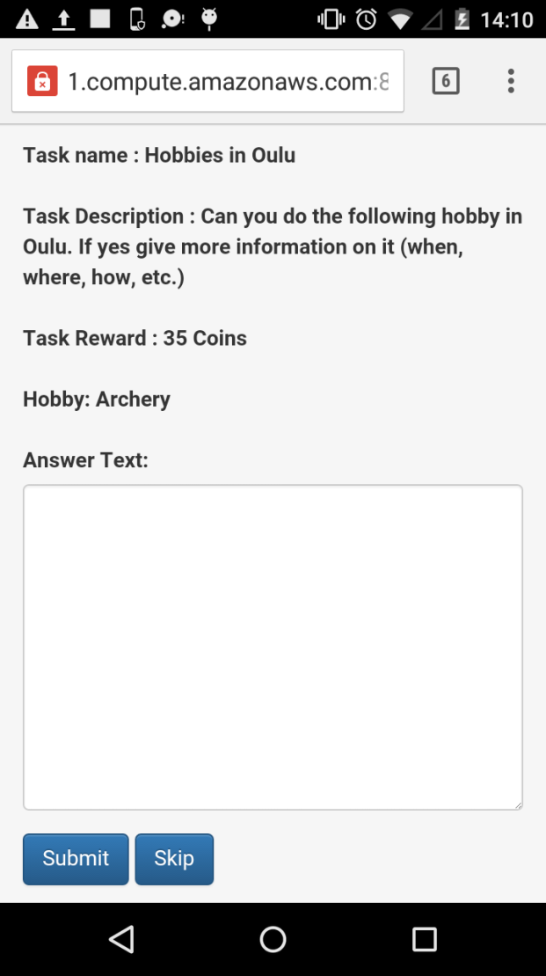

**Figure 6.2: Hobbies In Oulu Task Panel.**

**4.3.3. Student Housing**

Student Housing is another task, which resides under the category of Situated/Local Knowledge crowdsourcing task. PSOAS is a student housing organization that provides students with housing in an affordable price. There are multiple location in Oulu where the student villages or housing are being built by PSOAS, the organization provide shared apartments, family apartments and Studio apartments along with electricity, water and internet connection. They also answer to tenant’s fault reports if there is any maintenance problem in the apartment. In this task a worker is required to have knowledge of different location where the student villages by PSOAS are built and they need to rate the place as per different measures i.e., cleanliness, nearby services, location, cost, internet and maintenance by selecting rating scale i.e., Very Bad, Bad, Neutral, Good, Very Good, and Don’t Know. The task can be submitted from anywhere and it consists of 11 different names of the locations where PSOAS have developed the student villages.

A worker is required to have a good understanding and knowledge of the area and could be local resident or any international resident. The task worth 50 coins which is paid to the worker upon successful submission of the task and in case of skipping the task no coins are awarded to the worker.

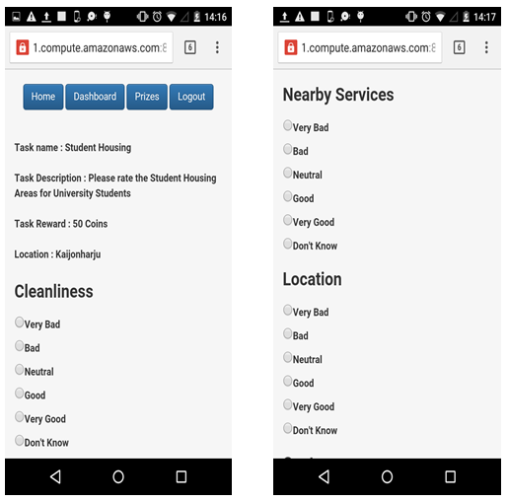

**Figure 6.3 Student Housing Task Panel**

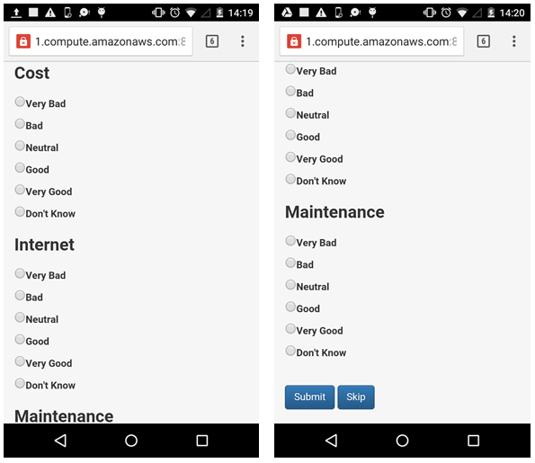

**Figure 6.3.1 Student Housing Task Panel**

**4.4 Location-Based Crowdsourcing Tasks**

In CrowdPickUp crowdsourcing platform another category of crowdsourcing pickup tasks are Location-based crowdsourcing tasks. The workers are allowed to pick their favorite locations from the Location-based task panel from the list of different locations as can be seen in Figure 6.4 from the City Of Oulu where the workers needs to be physically present at that location in order to submit the tasks. The workers are required to have initial knowledge of famous areas and places of the City Of Oulu i.e., beaches, super markets and university campuses etc., However the task panel also have a Google Map which can be seen in Figure 6.4.1 to guide and help them find the places and a clear picture of the location is also shown in the task panel to make workers easily recall the location.

The workers will be given general question related to the place i.e., how noisy and crowded the place is, how is the weather, is there any good local food restaurant nearby, what is the traffic situation of the place the worker is visiting, the available services present there, and weather the location is easy to find or not by using scales i.e., Very Bad, Bad, Neutral, Good and Very Good, the task completion reward is 250 Coins. There is no skip functionality in Location-based tasks as the worker can pick a favorite location of his/her choice from the list shown in the task panel.

**4.4.1 Google Map API**

In CrowdPickUp, Location-based crowdsourcing pick-up tasks are designed which require the current location of the user in order to submit the task. The GPS location co-ordinates needs to be translated into physical address of the current location that consist of complete Street Address, City, Country and Postal Code. In order to implement this functionality Google Map Api has been used, in which upon the task submission the system first makes an ajax request to Google Map Api and receives a response which contains the complete address where the user is currently present and then compare it with the address generated by CrowdPickUp Location-based task. The GPS (Global Positioning System) is a pre-requisite and should be activated for the participants in order to submit the Location-based tasks.

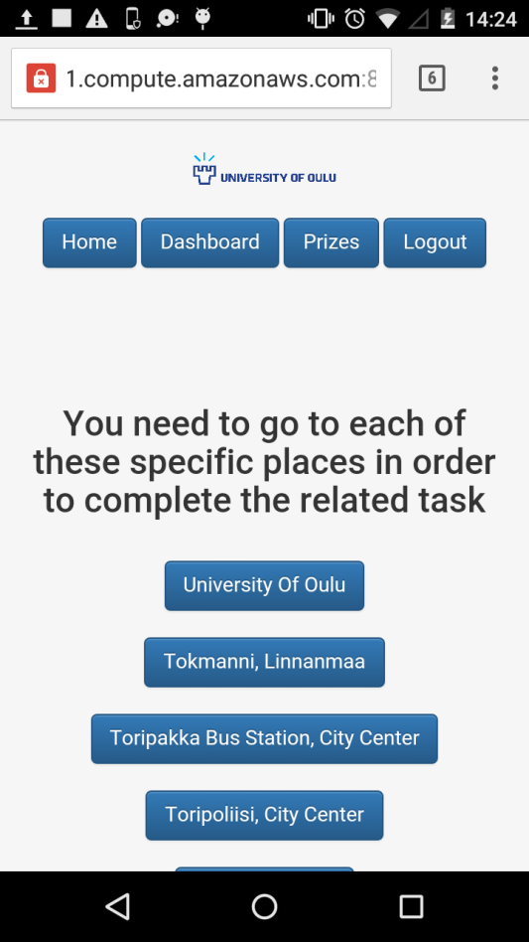 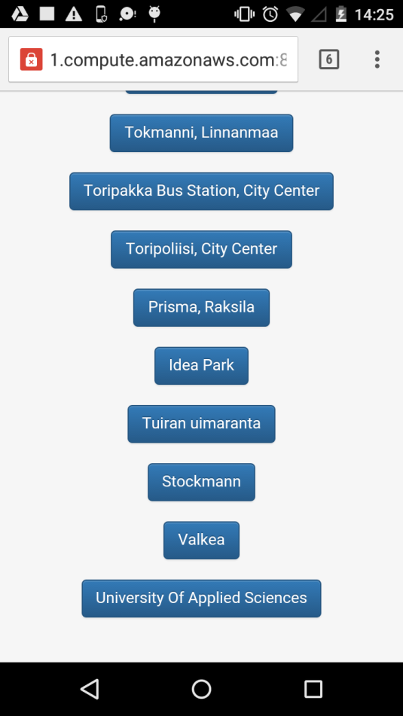

**Figure 6.4 Location-based Task Panel**

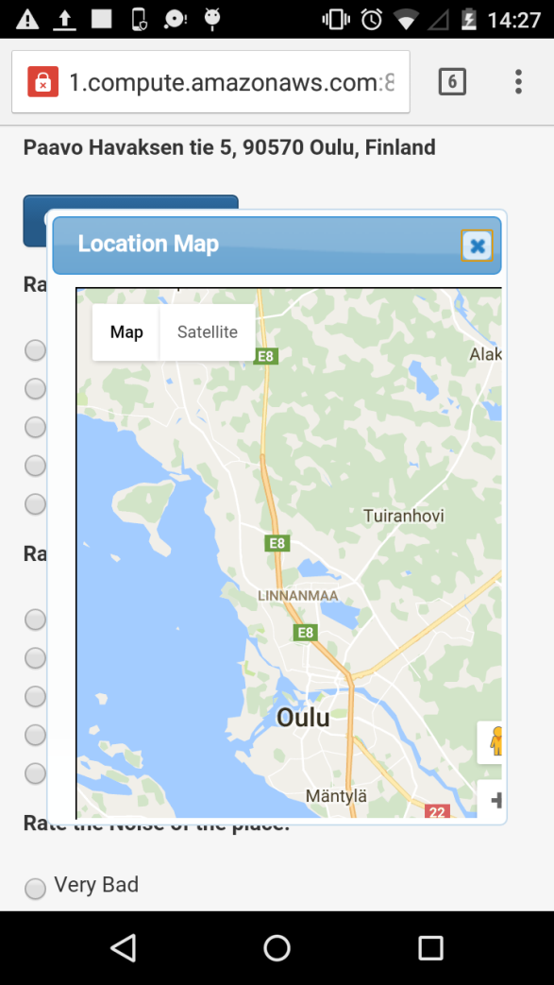

**Figure 6.4.1 Location-based Task Panel with Google map**

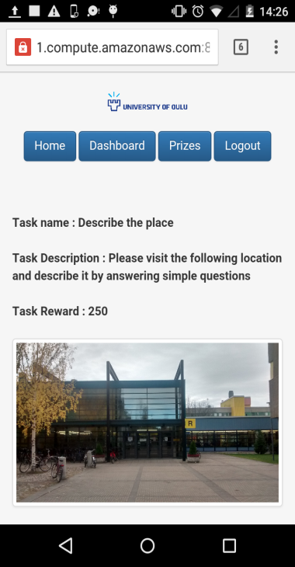 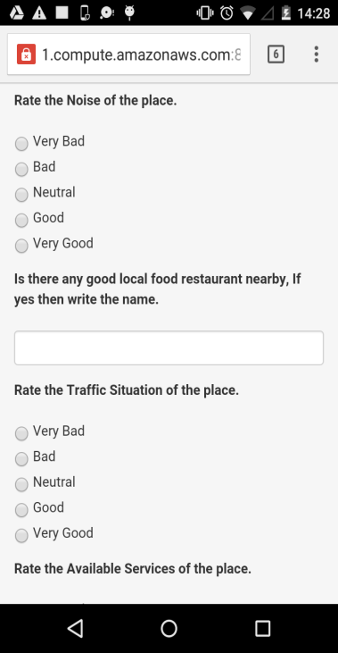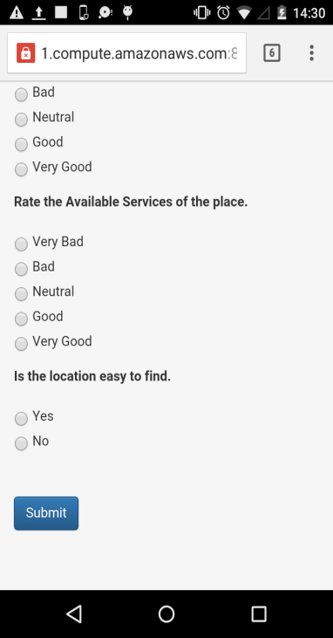

**Figure 6.4.2 Location-based Task Panel with questions and ratings**

**4.5 General Tasks**

General tasks is another category of tasks in CrowdPickUp crowdsourcing platform, workers do not have any restrictions of location or local knowledge of the City Of Oulu or Finland. Every task that comes under the category of General Tasks can be completed and submitted at any time and from any place and require worker’s basic knowledge of analyzing visual images and textual sentences and phrases. General Task category panel can be seen in the Figure 6.5.

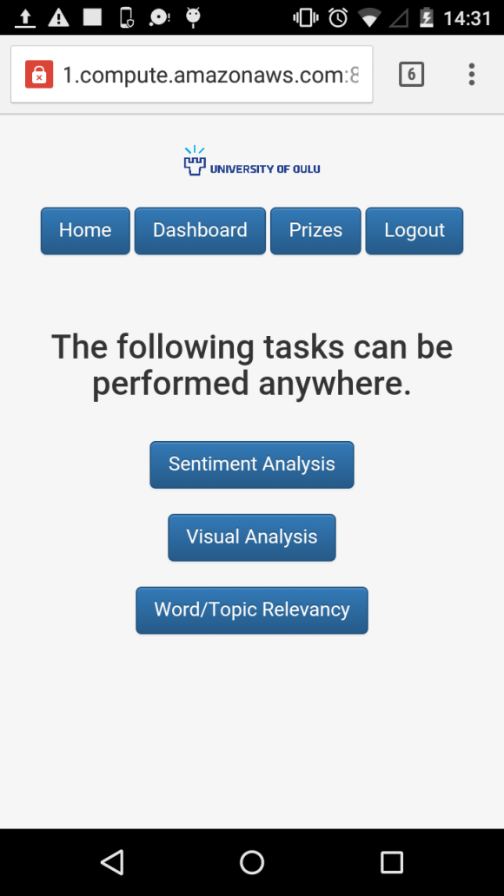

**Figure 6.5 General Tasks Category Panel.**

**4.5.1 Sentiment Analysis**

Sentiment Analysis is a way of analyzing and identifying someone’s opinion on a specific text or a topic. This technique is use to learn someone’s opinion or feedback about any text or a topic as negative, neutral or positive. In this task the worker is shown in the task panel with a sentence and three opinions i.e., negative, neutral and positive for the given sentence which he/she needs to pick in order to submit his/her opinion for the sentence as negative, neutral or positive.

The worker is awarded with 10 virtual coins for submitting each sentiment analysis task and upon skipping no coins are awarded and a new task is loaded to the task panel as soon as the task is submitted or skipped. The task is also backed with ground truths, for each task the ground truth is stored in the database and upon the submission of the worker’s opinion the system compares the submitted answer with the stored answer and mark the opinion as correct or incorrect upon submission. There are approximately 30 sentiment analysis tasks available for workers to complete. The task panel can be seen below in Figure 6.5.1.

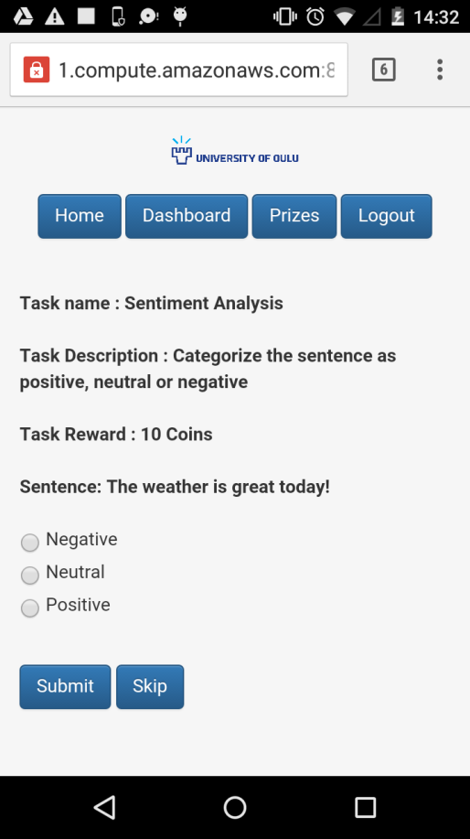

**Figure 6.5.1: Sentiment Analysis Task Panel.**

**4.5.2 Visual Analysis**

Visual Analysis is also known as Visual Inspection which means to observe physical and external features of any object without the use of any instrument to estimate the results and finding of its features. Visual Analysis resides under the general tasks category of CrowdPickUp crowdsourcing platform in which the workers will be shown an image of a place having two building marked with numbers i.e., 1 and 2 and the worker needs to analyze which building is closer of the two. The choices are shown on the task panel in the form of radio buttons which a worker can select to submit the task result. Visual Analysis is also backed with a ground truth saved in the backend database and upon task submission the submitted tasks answer is matched with the ground truth to identify whether the opinion is correct or not.

Upon each task submission, the worker is rewarded with 10 Coins and upon skipping the task no coins are awarded to the worker. The worker is required to have basic knowledge of visualizing things and the task can be submitted from anywhere and at any time. There are approximately 30 tasks available for workers to complete. Visual Analysis task panel can be seen in the below Figure 6.5.2.

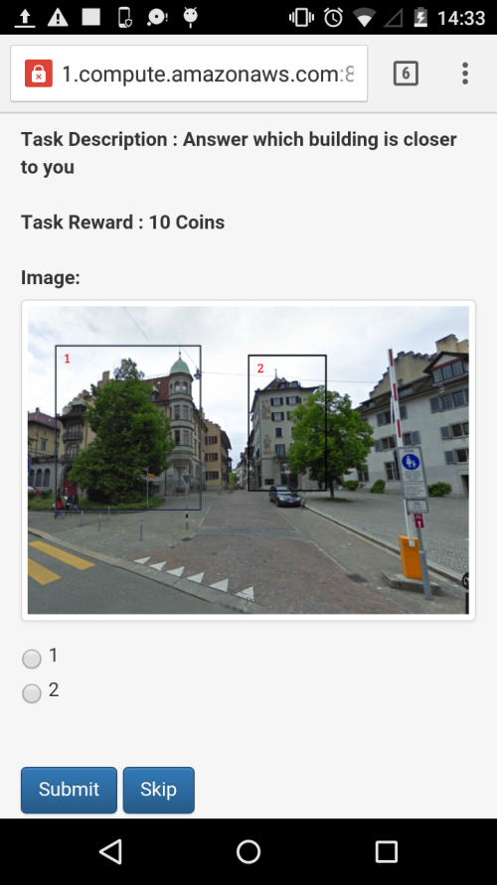

**Figure 6.5.2: Visual Analysis Task Panel.**

**4.5.3 Word/Topic Relevancy**

Word/Topic relevancy is another task that comes under the category of General Tasks in CrowdPickUp crowdsourcing task pick-up platform. The workers are shown a sentence along with three words and he/she needs to pick the best choice amongst the three words in order to submit the task. For the task completion, the workers are required to have a good command on English language and good knowledge of reading and understanding sentences and phrases.

Each task costs 10 coins that as a reward to the workers upon the task completion and no coins are awarded in case a task is skipped. The task is supported with a ground truth and the submitted task’s answer is compared with the ground truth to identify whether the submitted answer is correct. There are approximately 28 sentences and/or phrases and 80 words available in the platform for the workers. The Word/Topic relevancy task panel can be seen in the Figure 6.5.3 below.

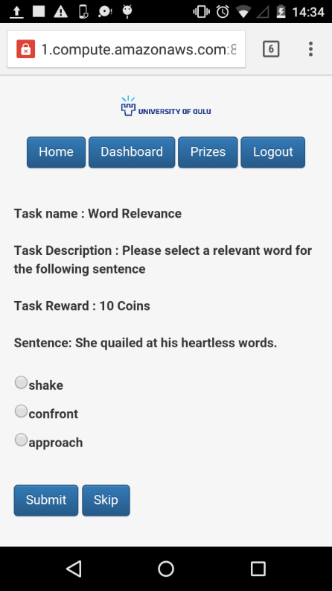

**Figure 6.5.3: Word/Topic Relevancy Task Panel.**

**4.6 Survey**

In CrowdPickUp crowdsourcing platform a survey is designed to gather information of the participant of our study. It helps the study to determine the characteristics of the population of the participants who took part in our research study, several open ended questions are asked in the survey questionnaire.

Every participant is allowed to fill the survey questionnaire only once and got the highest coins as a reward i.e., 300 Coins. The survey questionnaire asks from the participants following questions:

* Gender
* Age
* Education
* Field Of Study
* Living in Oulu
* Past crowdsourcing experience
* Personality statements
  + Is reserved
  + Generally trusting
  + Tends to be Lazy
  + Feel relaxed and handles stress well
  + Having artistic interests
  + Outgoing and Sociable
  + Tends to find faults with others
  + Does a thorough job
  + Gets nervous easily
  + Has an active level of imagination

A sample survey Questionnaire can be seen in the Figures below.

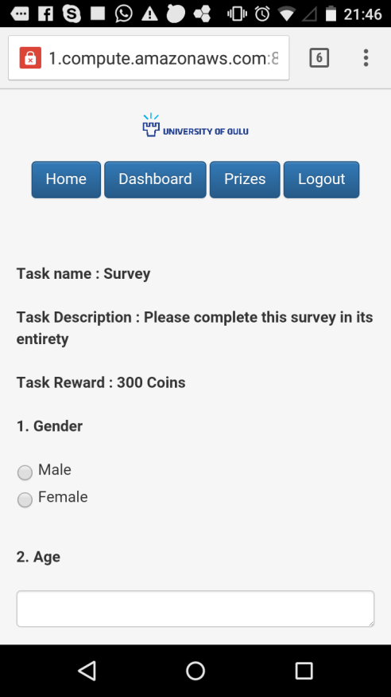 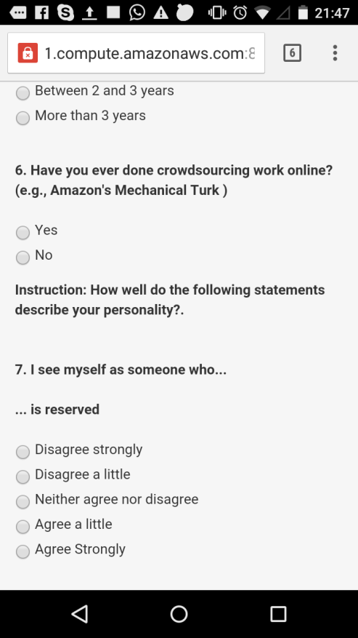

**Figure 6.6 CrowdPickUp Survey Screenshot.**

# Results

**5.1 General Statistics**

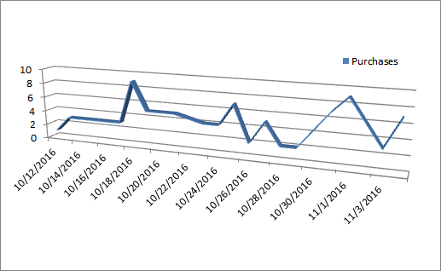

**Figure 6.7 CrowdPickUp User Purchases Statistic Plot.**

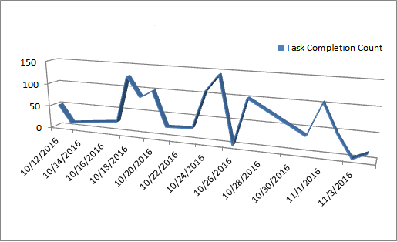

**Figure 6.8 CrowdPickUp Hobbies In Oulu Task Statistics Plot.**

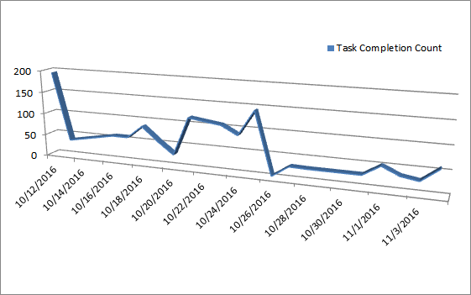

**Figure 6.9 CrowdPickUp Visual Analysis Task Statistics Plot.**

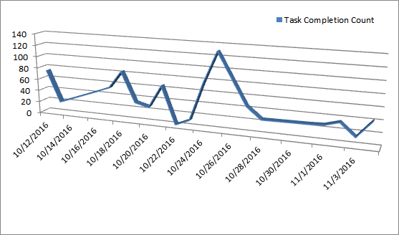

**Figure 6.10 CrowdPickUp Word/Topic Relevancy Task Statistics Plot.**

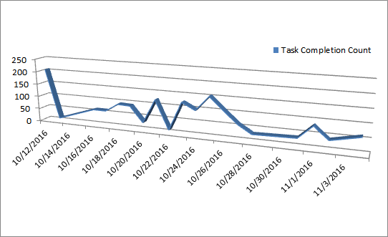

**Figure 6.11 CrowdPickUp Sentiment Analysis Task Statistics Plot.**

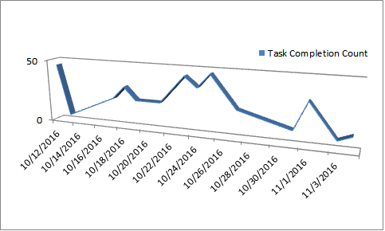

**Figure 6.12 CrowdPickUp Student Housing Task Statistics Plot.**

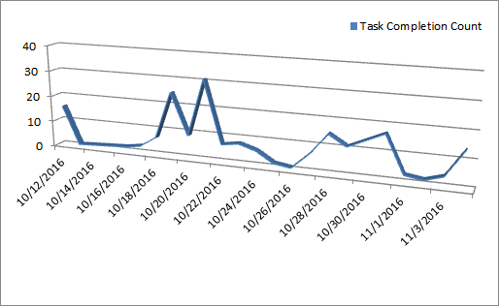

**Figure 6.13 CrowdPickUp Location-based Tasks Statistics Plot.**

**5.2 Survey Results**

CrowdPickUp contains a survey task for the participants to know about the population of our participants and their information through our study as described earlier in section 4.6. Approximately, out of total 70 participants, 47 of the participants fill out the survey task. This section of the chapter will give an insight about our participant’s age, gender, their education level and their field of study etc.

From Total out of 47 participants, most of participants from the age group of 20-25 and 25-30 years of age participate in the study. Very few participants use the application, which belongs to the age group of 15-20, 30-35 years 35-40 years of age. From the bar graph, it can be conclude that participants from every group of ages participate in the study and use our CrowdPickUp crowdsourcing system. Amongst the participants 8.5% of the participants belong to the age group of 15-20 years, 40.42% of the participants are between the age group of 20-25 years, 32% are between the age group of 25-30 years, 12.7% lies between the age of 30-35 years and 6.38% of the participants are between the ages of 35-40 years. Most of the application users are male i.e., 74% and very few are females i.e., approximately 26%.

The participants of CrowdPickUp crowdsourcing task-pickup system are from various education backgrounds i.e., Bachelors, Master and Doctoral and High school studies etc. and from number of different field of studies i.e., Science, Engineering, Economics and Arts etc. Amongst the participants who submitted the surveys 29.78% are from Bachelor’s degree, 44.68% belongs to Master’s degree studies, 4.25% are from Doctoral Degree Studies and 21.27% of the participants are from High School and Lower education level. As far as the participant’s fields of studies are concerned 19.14% of participants are from IT-Related background, 6.38% are from Economics background, 4.25% of participants are from Science background, 34.04% are from Engineering background, 10.63% of the participants are from Arts background and 25.53% of the participants belongs to Other fields of studies than described earlier.

Through CrowdPickUp crowdsourcing system’s survey, we investigate for how long participants are living in Finland. The statistics says that 14.89% of the participants live in Finland for less than 1 year, 25.53% of the participants live for the time period of between 1 and 2 years, 14.89% between 2 and 3 years, whereas most of the participants are living in Finland for more than 3 years i.e., 44.68%.

Through CrowdPickUp survey we also investigate whether our participants have any prior crowdsourcing experience before and the statistics shows that most of our participants are new to crowdsourcing platforms and the very first time they are working with crowdsourcing platform. In this way, our application introduce a new platform to the users through our CrowdPickUp crowdsourcing task-pickup platform. The statistics shows that 91.48% of participants have no prior experience of working with crowdsourcing platforms and only 8.51% of them have worked on such systems before.

**5.3 Performance**

This section demonstrates the performance evaluation of different tasks of our CrowdPickUp crowdsourcing task-pickup system. The following table shows the different tasks of CrowdPickUp crowdsourcing system along with each individual task’s average time in seconds, the standard deviation to quantify the amount of variation and accuracy.

|  |  |  |  |
| --- | --- | --- | --- |
| **Tasks** | **Time (Average)** | **Time (S.D)** | **Accuracy** |
| Object Translation | 24.80 secs | 23.62 secs | 73.54% |
| Sentiment Analysis | 5.80 secs | 6.22 secs | 24.22% |
| Visual Analysis | 7.65 secs | 11.41 secs | 70.66% |
| Word/Topic Relevancy | 14.36 secs | 18.94 secs | 65.75% |
| Student Housing | 23.95 secs | 16.58 secs | **--** |
| Hobbies In Oulu | 29.53 secs | 46.86 secs | **--** |
| Location-based Tasks | 47.42 secs | 34.84 secs | **--** |

**Table 1. Time and Accuracy table of CrowdPickUp Tasks.**

As can be seen in the above table the tasks which have their accuracies calculated, amongst them Object Translation Task is having the highest accuracy and Sentiment Analysis has the lowest accuracy whereas Visual Analysis and Word/Topic Relevancy has reasonable accuracies. As far as Time is concerned Location-based tasks have the highest completion time due to the length of the tasks and Sentiment Analysis Tasks have the lowest time completion.

Sentiment Analysis, Visual Analysis and Word/Topic Relevancy have their ground truths saved in the database and the submitted answers matched with the ground truths to identify the correct answer whereas in Object Translation Task the correct and wrong answers identified manually. The rest of the tasks i.e., Student Housing, Hobbies In Oulu and Location-based Tasks are not backed with ground truths as their submissions are based on users opinion that is why their accuracies are not calculated and provided.

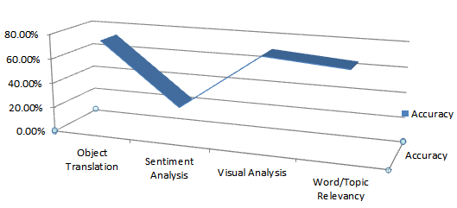

**Figure 6.8. CrowdPickUp Tasks Accuracy Plot.**

# Conclusions

The conclusion section/text will go here

# references

[1] Vukovic, M., Kumara, S., Greenshpan, O. Ubiquitous crowdsourcing. In Adj. Proc. Ubicomp '10, ACM (2010), 523-526.

[2] Eagle, N.: txteagle: Mobile Crowdsourcing. In Proc. of Human-Computer Interaction International (HCII), vol. 5623, pp.447-456, San Diego, CA, July 2009.

[3] Konomi, S., Thepvilojana, N., Suzuki, R., Pirttikangas, S., Sezaki, K., Tobe, Y.: Askus Amplifying Mobile Actions. Proc. Pervasive 2009, pp. 202-219.

[4] Alt, F., Shirazi, A., Schmidt, A., Kramer, U., Nawaz, Z. Location-based crowdsourcing: extending crowdsourcing to the real world. In Proc. NordiCHI '10, ACM (2010), 13-22.

[5] Gupta, A., Thies, W., Cutrell, E., Balakrishnan, R. mClerk: enabling mobile crowdsourcing in developing regions. In Proc. CHI '12, ACM (2012), 1843-1852.

[6] Rogstadius, J., Kostakos, V., Kittur, A., Smus, B., Laredo, J. Vukovic, M. An Assessment of Intrinsic and Extrinsic Motivation on Task Performance in Crowdsourcing Markets. In Proc. ICWSM’11, AAAI (2011), 321-328.

[7] Deci, E. 1975. Intrinsic Motivation. New York: Plenum Press. Etzioni, A. 1971. Modern Organizations. Englewood Cliffs, NJ: Prentice-Hall.

[8] Chandler, D. and Kapelner, A. May 2010. Breaking Monotony with Meaning: Motivation in Crowdsourcing Markets, working paper, <http://www.danachandler.com/files/Chandler_Kapelner_BreakingMonotonyWithMeaning.pdf>.

[9] Mason, W. and Watts, D. June 2009. Financial incentives and the performance of crowds.

[10] Kaufmann, N., Schulze, T., Viet, D. More than fun and money. Worker Motivation in Crowdsourcing – A Study on Mechanical Turk. In Proc. AMCIS’11 (2011).

[11] Yuen, M, King, I., Leung, K. Task Matching in Crowdsourcing. In Proc. iThings/CPSCom '11. IEEE (2012).

[12] Allahbaksh, M., Benatallah, B., Ignjatovic, A, Motahari-Nezhad, H., Bertino, E., Dustdar, S. Quality Control in Crowdsourcing System Issues and Directions.

[13] Kittur, A., Chi, E., Suh, B. Crowdsourcing user studies with Mechanical Turk. In Proc. CHI '08. ACM (2008), Pages 453-456.

[14] peirotis, N. Demographics of Mechanical Turk (2010), <http://archive.nyu.edu/bitstream/2451/29585/2/CeDER-10-01.pdf>

[15] Liu D., Bias R., Lease M., Kuipers R. Crowdsourcing for usability testing. In Proc. Of AIST ‘2012, Pages 1-10.

[16] Winter, J.C.F., Kyriakidis, M., Dodou, D., Happee, R. Using CrowdFlower to study the Relationship between Self-reported Violations and Traffic Accidents.

[17] Goncalves, J., Ferreria, D., Hosio, S., Liu Y., Rogstadius, J., Kukka, H., Kostakos, V. Crowdsourcing on the spot: altruistic use of public displays, feasibility, performance, and behaviours. In Proc. Ubicomp '13, ACM (2013), 753-762.

[18] Horton, J., Chilton, L. The labor economics of paid crowdsourcing. In Proc. EC '10, ACM (2010), 209-218.

[19] Kazai, G., kamps, J., Milic-Frayling, N. Worker types and personality traits in crowdsourcing relevance labels. In Proc. CIKM '11. ACM (2011), 1941-1944.

[20] Kittur, A., Smus, B., Khamkar, S., Kraut, R. CrowdForge: crowdsourcing complex work. In Proc. UIST '11. ACM (2011), 43-52.

[21] Pelt, C., Sorokin, A. Designing a scalable crowdsourcing platform. In Proc. UIST '11. ACM (2011), 43-52.

[22] Oleson, D., Sorokin, A., Laughlin, G., Hester, V., Le, J., Biewald, L. Programmatic Gold: Targeted and Scalable Quality Assurance in Crowdsourcing. In Human Computation AAAI Workshop '11.

[23] Gadiraju, U., Kawase, R., Dietze, S., Demartini, G. Understanding Malicious Behavior in Crowdsourcing Platforms: The Case of online surverys. In Proc. CHI '15. ACM (2015), 1631-1640.

[24] Allahbaksh, M., Benatallah, B., Ignjatovic, A, Motahari-Nezhad, H., Bertino, E., Dustdar, S. Quality Control in Crowdsourcing System Issues and Directions.

[25] Kittur, A., Khamkar, S., Andre, P., Kraut, R. CrowdWeaver: visually managing complex crowd work. In Proc. CSCW '12. ACM (2012), 1033-1036.

[26] Hosio, S., Goncalves, J., Lehdonvirta V., Ferreria, D.,Kostakos, V. Situated crowdsourcing using a market model. In Proc. UIST '14. ACM (2014), 55-64.

[27] Goncalves, J., Hosio, S., Ferreria, D., Kostakos, V. Game of words: tagging places through crowdsourcing on public displays. In Proc. DIS '14. ACM (2014), 705-714.

[28] Huang, Y. Designing a Micro-Volunteering Platform for Situated Crowdsourcing. In Proc. CSCW '15. ACM (2014), 73-76.

[29] Goncalves, J., Hosio, S., Kostakos, V., Vukovic, M., konomi, S. Workshop on mobile and situated crowdsourcing. In Proc. UbiComp/ISCW '15 Adjunct. ACM (2015), 1339-1342.

[30] Goncalves, J., Hosio, S., Liu, Y., Kostakos, V. worker performance in a Situated Crowdsourcing Market.

[31] Goncalves, J., Hosio, S., Ferreria, D., Anagnostopoulos, T., Kostakos, V. Bazaar: a situated crowdsourcing market. In Proc. UbiComp/ISCW '15 Adjunct. ACM (2015), 1385-1390.

[32] Goncalves, J., Hosio, S., Rogstadius, J., Karapanos, E., Kostakos, V. Motivating participation and improving quality of contribution in ubiquitous computing.

[33] Goncalves, J., Hosio, S., Ferreria, D., Anagnostopoulos, T., Kostakos, V. Crowdsourcing performance evaluations of user interfaces. In Proc. CHI '13. ACM (2013), 207-216.

[34] Goncalves, J., Hosio, S., Ferreria, D., Anagnostopoulos, T., Kostakos, V. No “one-size fit all”: towards a principled approach for incentives in mobile crowdsourcing. In Proc. HotMobile '14. ACM (2014).

[35] Chaudhry, S. Indoor location estimation using an NFC-based crowdsourcing approach for bootstrapping.

[36] T. Yan, M. Marzilli, R. Holmes, D. Ganesan, and M. Corner. mcrowd: a platform for mobile crowdsourcing. In SenSys ’09, pages 347–348. ACM, 2009.

[37] Vaish, R., Wyngarden, K., Chen, J., Cheung, B., Bernstein, M. Twitch Crowdsourcing: crowd contributions in short burst of time. In Proc. CHI '14, pages 3645-3654. ACM (2014).

[38] Do, N., HSU, C., Venkatasubramanian, N,. CrowdMAC: A Crowdsourcing System for Mobile Access. In Proc. IMC '12.

[39] Narula, P., Gutheim, P., Rolnitzky, D,. Kulkarni, A., Hartmann, B,. MobileWorks: A Mobile Crowdsourcing Platform for Workers at the Bottom of the Pyramid.

[40] Govindaraj, D., K.V.M, N., Nandi, A., Narlikar, G., Poosala, V. MoneyBee: Towards enabling a ubiquitous, efficient, and easy-to-use mobile crowdsourcing service in the emerging market.

[41] Feng, Z., Zhu, Y., Zhang, Q., Ni, L., Vasilakos, A. TRAC: Truthful auction for location-aware collaborative sensing in mobile crowdsourcing.

[42] Chen, Z., Fu, R., Zhao, Z., Liu, Z., Xia, L., Chen, L., Cheng, P., Cao, C., Tong, Y., Zhang, C. gMission: A general spatial crowdsourcing platform. In Proc. VLDB ’14, pages 1629–1632.

[43] Goncalves, J., Kukka, H., Sanchez, I., Kostakos, V. Crowdsourcing Queue Estimations in Situ. In Proc. CSCW ’16, pages 1040–1051, ACM (2016).

[44] Misu, T. Crowdsourcing for Situated Dialog Systems in a Moving Car. In Proc. INTERSPEECH ’14.

[45] Zambonelli, F,  (2011) Pervasive urban crowdsourcing : Vision and challenges. In Proc. PERCOM, 2011.

[46] Marshall, Paul, Cain, Rebecca and Payne, Sarah R. (2011) Situated crowdsourcing : a pragmatic approach to encouraging participation in healthcare design. In Proc. Of Pervasive Health, pages 555-558, 2011.

[47] Alario-Hoyos, C, Pérez-Sanagustín, M, Delgado-Kloos, C. Supporting crowdsourcing in MOOC informal face-to-face meetings. In Proc. WEILER ‘2013.

[48] Ludwig. T, Kotthaus, C, Pipek, V. Situated and ubiquitous crowdsourcing with volunteers during disasters. In Ubicomp ’16, pages 1441–1447. ACM, 2016.

[49] Huang, Y, Shema, A, Xia, H. A proposed genome of mobile and situated crowdsourcing and its design implications for encouraging contributions, 2016.

[50] Misu, T. Cain, Rebecca and Payne, Sarah R. (2015) Visual Saliency and Crowdsourcing-based Priors for an In-Car Situated Dialog System. In Proc. Of ICMI ‘2015, pages 75-82, 2015.

[51] Hosio S., Goncalves J., Barkel V., Klakegg S. (2016) Crowdsourcing situated & subjective knowledge for decision support. In Proc. Of Ubicomp ‘2016, pages 1478-1483, 2016.

[52] Sasao T., Konomi S., Suzuki R. (2016) Supporting community-centric use and management of vacant houses: a crowdsourcing-based approach. In Proc. Of Ubicomp ‘2016, pages 1454-1459, 2016.

[53] Micholia P., Karaliopoulus M., Koutsopoulos I., Aiello L., Morales G., Quercia D. (2016) Incentivizing social media users for mobile crowdsourcing, 2016.

[54] Yang D., Xue G., Xi F., Tang J. (2012) Crowdsourcing to smartphones: Incentive mechanism design for mobile phone sensing. In Proc. Of Mobicom ‘2012, pages 173-184, 2012.

[55] Chatzimilioudis G., Kostantinidis, A., Laoudias, C., Zeinalipour-yazti D. Crowdsourcing with smartphones. IEEE Internet Computing (2012).

[56] Yan, T., Hoh, B., Ganesan, D., Tracton, K., Iwuchukwu, T., Lee, J.-S., Crowdpark: A crowdsourcing-based parking reservation system for mobile phones. University of Massachusetts at Amherst. Technical Report, 2011.

[57] Tan, E., Xia, H., Ji, C., Joshi, R.V., Huang, Y., Designing a mobile crowdsourcing system for campus safety. iConference 2015 Proceedings, Irvine, CA, USA, 2015.

[58] Luon, Y., Aperjis, C., Huberman, B.A., 2011. Rankr: A mobile system for crowdsourcing opinions. Mobile Computing, Applications, and Services. Springer, pp. 20–31 lyft, 2015. A ride whenever you need one—lyft. [Online; accessed 23-September-2015]. <https://www.lyft.com/>

[59] Wu, D., Zhang, Y., Bao, L., Regan, A. Location-Based Crowdsourcing for Vehicular Communication in Hybrid networks. IEEE Transactions on Intelligent Transportation Systems (2013).

[60] Vaataja, H., Vainio, T., Sirkkunen, E. Location-based crowdsourcing of Hyperlocal news: dimensions of participation preferences. In Proc. Of GROUP ‘2012, pages 85-94, 2012.

[61] Bulut, M., Yilmaz, Y., Demirbas, M. Crowdsourcing location-based queries. PERCOM Worshops ’11, IEEE (2011).

[62] Goodchild, M., Gelnnon, J. Crowdsourcing geographic information for disaster response: a researcher frontier. International Journal of Digital Earth, pages 231-241, 2010.

[63] Rai, A., Chintalapudi, K., Padmanabhan, V., Sen, R. Zee: zero-effect crowdsourcing for indoor localization. In Proc. Mobicom ’12, pages 293-304, ACM (2012).

[64] Wu, C., Yang, Z., Liu, Y. Smartphones Based Crowdsourcing for Indoor Localization. IEEE Transactions on Mobile Computing, pages 444-457, IEEE (2014),

# appendices

The appendices section/text will go here.

[](http://www.oulu.fi/yliopisto/)

Figure 1. University logo.